Final Document

Carrot Quest

By: Ariana Brown, James McGuigan, Steven Foster, Jugraj, Adan

Introduction: 3
Implementation: 3
Game Design and Changes: 4
Initial Game Considerations 4
Initial Design 4
First Revision 4
Second Version 5
Version Three 5
Final Version 6
Game Development Stages: 6
Initial Design: 6
Questions we wanted to solve in pre-development: 6
Game Mechanics / Code Structure: 6
Movement and Physics: 6
Platform and Obstacle Generation: 7
Procedural Generation: 7
User Experience: 8
User Input: 8
Audio Management: 8
Game State Management: 8
Performance and Optimization: 9
Rendering and Update Loop: 9
Scalability and Extensibility: 9
Design Considerations We faced in post-development: 9
Improvements and Future Development: 9
Challenges we faced in Game Development: 10
Lessons in game development within a team: 10
User Guide 11
Menu Options 11
System Requirements 11
How to Play 12
1. Starting the Game: 12
2. Controls: 13
3. Gameplay: 14
Features and Mechanics 15
1. Dynamic Background: 15
2. Physics-Based Movement: 15
3. Scoring System: 15
4. Game Over Conditions: 15
5. High Scores: 15
Tips and Tricks 16
Contributions to the project 17
Project Link: 19

Introduction:
Carrot Quest is an endless 2D scroller game that all ages can play with ease. The game has a simple to understand concept and easy accessibility which makes it a perfect game for you and your friends to play. The game is a single player game. The main character in our game is a rabbit that is in search of carrots. Users will jump on Carrot Platforms and collect as many carrots as possible. As the rabbit jumps higher into the air, obstacles such as bombs will begin to obstruct the player's path. It is up to the player to use their critical thinking skills to avoid all obstacles. Failure to land on a platform or hitting a bomb will lead to the rabbit dying and the game over screen will pop up. It is the player's goal to jump on as many carrots as possible and get the best score possible. How many carrots can you collect?

Implementation:
Once our game was approved by Mr.Park, we began with implementation. Before our team started coding, we first needed to decide on what the main programming language for game would be developed in. After discussing the pros and cons within each coding language we ultimately decided to develop Carrot Quest in Java. We chose Java because everyone in our team had experience in using java. So, we were confident in creating a fun game using java.

As stated in the design document, Carrot Quest was made using Java Script, with HTML for the visuals that end users see in the web browser. We used PHP to allow our website to interact with our database. Carrot Quest has a scoring system that allows players to compete with other players to see who can collect the most carrots.
Before creating the game we believed that we should delegate a leader to help stay organized. We as a team felt that James McGuigan was best fit to be the leader during this project because of his vast knowledge in computer science and his ability to efficiently be able to delegate roles. A leader was essential for this project to prevent people working on the same thing. While developing the game we all downloaded Sublime Text and sent over all new code we had written.
Carrot Quest always planned to be a game that had a scoring system. However, we originally planned the game to utilize local data on the computer. The advantage of using local data was it was difficult to have security breaches with the game. Each computer had its own data and no data was shared between two computers. However, players could only play against themselves and not other players. We felt that this had to change because when creating Carrot Quest we wanted it to be a competitive game you can play with friends. So we decided to make a server with Ubuntu as the operating system. We implemented SSH traffic to make the website safe from any breaches. Now, when you play Carrot Quest you can look at a global leaderboard that shows the high scores of any players that played Carrot Quest. We hope this implementation allows our users to have a funner experience with our game.
All code was done separately by each teammates. The only exception was when someone experienced a bug or error, then another teammate would assist them. We felt that it was best that everyone should code in areas that they felt most comfortable in. This allowed for minimal confusion when creating Carrot Quest. Collaborating in this way, while also assisting each other allowed this project to run smoothly.
To play this game, you will need to go to this link: http://ec2-52-87-244-187.compute-1.amazonaws.com/CarrotQuest.html
This can also be found in the comment section on brightspace. Where we submitted this assignment.
To see the code of Carrot Quest:
Please press the github link provided and press “Code”

Game Design and Changes:

Initial Game Considerations
- A fighting game styled after Street Fighter
- A Flappy Birds-style game
- A Doodle Jump-inspired game, we selected this option.

Initial Design
- The game loop centered around jumping up from platform to platform and collecting points.
- The player bounced in place and was guided side to side.
- The game loaded all new instances over the old instance.

First Revision
- All screens were fleshed out with backgrounds
- The main game screen was given a moving background
- The pause menu was implemented

Second Version
- The high-score system was designed, but some implementation issues existed without impacting the gameplay
- Randomly placed obstacles were implemented
- The pause menu was mapped to p as well as esc
- The exit menu for the game gained functionality with the high-score system
- The first interaction of sound was added

Version Three
- The high-score system was implemented locally, but issues remained in linking to a high-score database.
- The instructions screen was fleshed out
- The pause menu added access to the instructions screen
- The sound was fully implemented with a toggle on the home screen and adjustable sliders added to the pause menu.
- Platform generation was adjusted to improve traversability for the player
- Object generation was adjusted to improve randomization in placement and reduce spawning issues.
- Game instances are now properly cleaned up and only one instance at a time is active.
- A new main game background was included, providing a looping screen rather than a long video.

Final Version
- The high Score system is fully implemented, and now communicating with the high score database.
- The high-score database is set up and functional.
- The game has been Hosted on AWS for ease of access for potential players.

Game Development Stages:

Initial Design:

Questions we wanted to solve in pre-development:
- Planning the game mechanics, such as rabbit movement, platform generation, and scoring system.
- What should be considered in development such as dynamic sizing to support different screen resolutions.
- How to design a physics system that allows for smooth/seamless character movement.

Game Mechanics / Code Structure:

Movement and Physics:
- We changed the parameters used to create gravity, jump force, acceleration, and deceleration from an initial bounce, acceleration, and gravity to include an element for velocity.
- Create smooth movement by using velocity calculations and interpolation, this was assisted after attending a lecture on “Python and Pizza” with Professor Ashok B. and a similar concept relating to data analytics and baseball.
- Allow for wraparound screen movement to create an infinite scrolling effect.
- Professor Khalifa inspired Jimmy to use delta-time for frame-independent physics calculations as part of another project within computer networking using a similar concept.

Platform and Obstacle Generation:

Procedural Generation:
- As a team, we decided to use a repeating system for dynamically generating platforms and obstacles assistance for creating the correct calculations for this system was assisted and checked by a Large Language Model and used for multiple parts of the project with minimal change between the platforms and objects to create a parameter which wouldn't overlap between object and platform. Our initial parameters had dynamic spawning which would overlap.
- The initial code presented an overlap of platform and object which was changed and corrected by the Language Models assistance.
- The use of methods to remove platforms and obstacles that have moved off-screen was developed to perform memory management preventing an excessive number of assets making it scalable.
- Use randomization to create varied and unpredictable gameplay.
- Ensure platforms are placed at appropriate intervals to maintain game challenge.

User Experience:

User Input:
- Allowing support for multiple input methods, arrow keys, and the A/D keys.
- Smooth acceleration and deceleration.
- Changing rabbit direction to show inputs via the 2 rabbit images.

Audio Management:
- Multiple audio tracks for different game states.
- Create volume controls with local storage to match user preferences.
- The adjusted volume was found as part of a project for a fighting game developed in Java.
- Use audio cloning for sound effects to prevent audio overlap.

Game State Management:
- Design a state machine to manage different game screens such as menu, instructions, gameplay, and game over.
- Including a pause functionality with a pause menu includes options commonly present within most games of similar standing.
- A smooth transition between the various states is present in the game.

Performance and Optimization:

Rendering and Update Loop:
- Smooth animation of the images and background working dynamically with the rest of the project.
- We included an implementation of a game loop that handles physics, rendering, and game logic to allow for restart functionality.
- Over time as we developed this project we optimized performance by minimizing unnecessary calculations for developing game pieces.

Scalability and Extensibility:

Design Considerations We faced in post-development:
- This allows functions to be easily modified or extended if future development takes place, inheritance, and extension to add to this game.
- The design of a scoring system can be expanded to include high-score tracking contained within a database.
- Infrastructure for potential future features like power-ups or multiple character choices over time.

Improvements and Future Development:
- Add more variety to the platform and obstacle generation to increase difficulty.
- Create power-ups or special items to increase gameplay complexity.
- Develop better recording scoring mechanisms.

Challenges we faced in Game Development:
- Balancing game physics for smooth and enjoyable gameplay.
- Creating a responsive design that works across different device sizes.
- Managing game state and ensuring smooth transitions.
- Implementing audio and visual feedback for error handling.
- Focusing on core mechanics before adding additional features.
- Continuously playtest and refine game feel and responsiveness.

Lessons in game development within a team:
- Game development requires multiple approaches to design, programming, and user experience
- Unforeseen responsibilities such as the necessity of team leadership, communication, and teamwork are important to the development process and documentation.
- Breaking down complex systems within code will make them more manageable objects and functions to build upon in the future.
- The importance of design and continuous improvement of a project, we have a start to develop something into a larger more complex project.

User Guide
- The Player Character - represented by the Rabbit. His goal is to complete his titular carrot quest.
- Platform - Some platforms are randomly generated throughout the game and are represented with carrots. The more carrots you reach, the more points you gain. If you miss a platform and fall to the ground, it's game over.
- Bomb - Bombs are also randomly generated in different places to act as the obstacle of the game. If the player comes in contact, it's game over.

Menu Options
- Play Game - Starts a new game.
- Instructions - Displays the instructions on how to play the game.
- High Scores - Displays the high scores of the game accumulated through previous attempts.
- Play Music - Controls the volume options for the music and sound effects of the game.
- Exit Game - Closes the game window.

System Requirements
- -Windows 7 OS or higher
- - Google Chrome
- -Integrated Graphics Card
- -Screen resolution

How to Play

1. Starting the Game:
- - Launch the game by opening the CarrotQuest.html file in any web browser.
- - On the main menu, click Play Game to start your adventure.
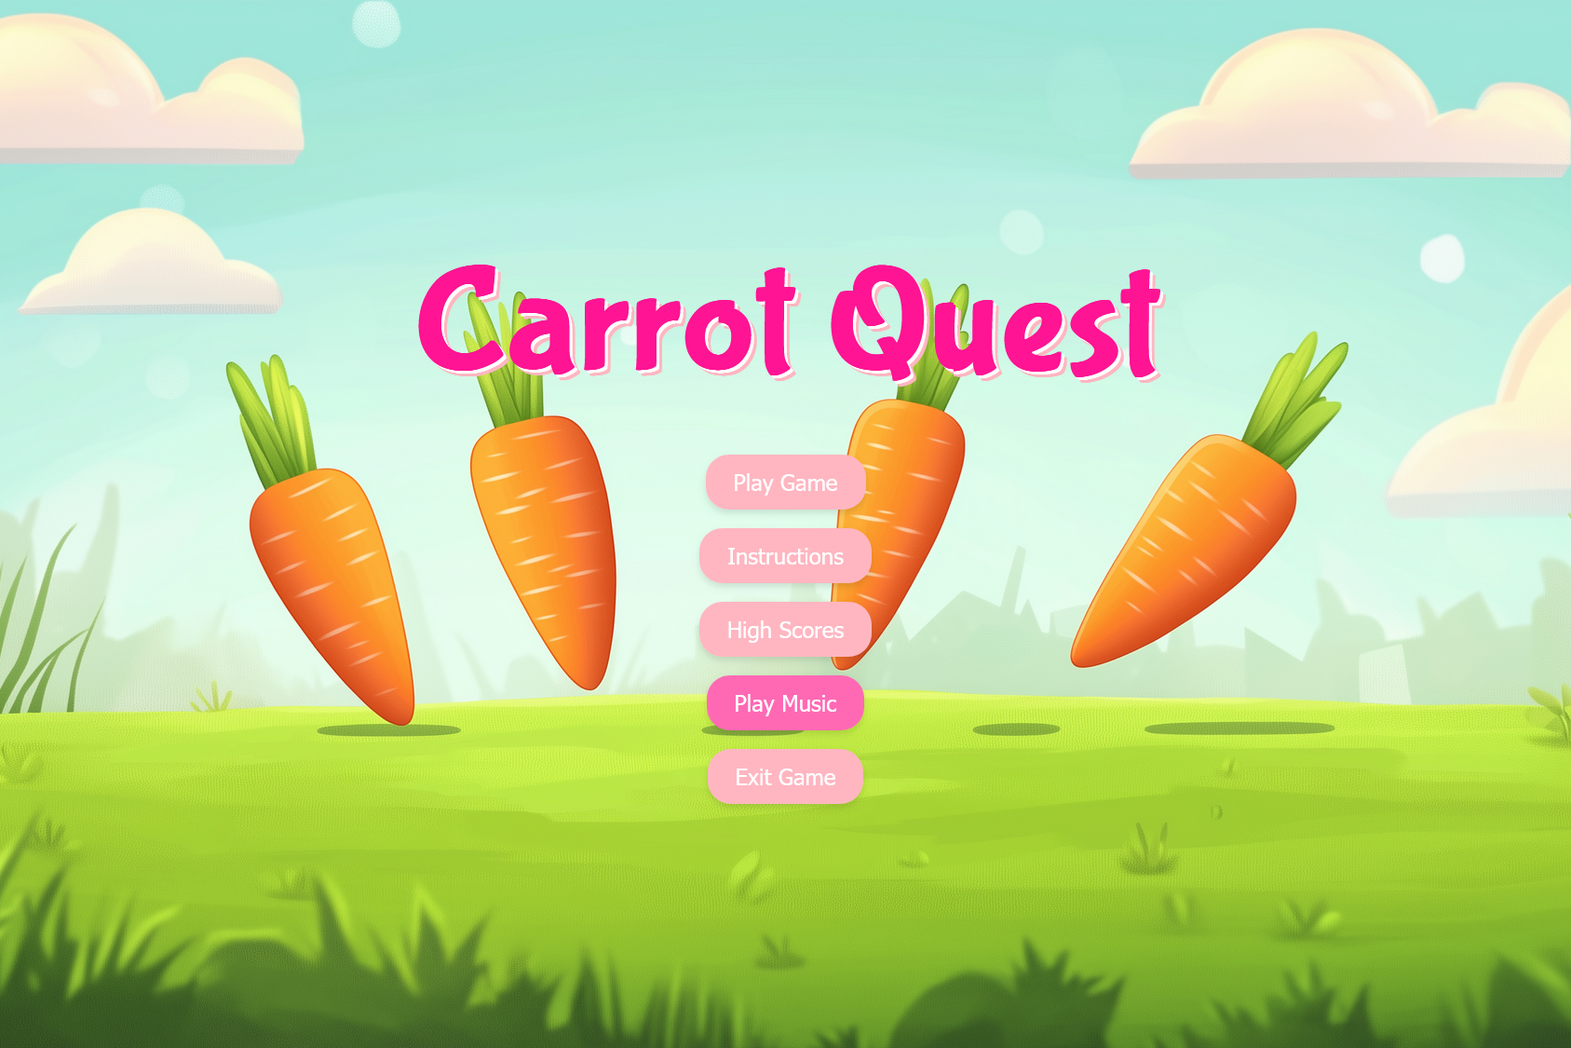

2. Controls:
- - Move Left: Use the left arrow key to move the rabbit to the left.
- - Move Right: Use the right arrow key to move the rabbit to the right.
- - Jumping is automatic when the rabbit lands on a platform.


3. Gameplay:
- - Platforms are spaced dynamically to challenge your reflexes and strategic movement.
- - Collect carrots to boost your score and aim to climb as high as possible.
- - Avoid bombs at all costs! Hitting one will end the game instantly.
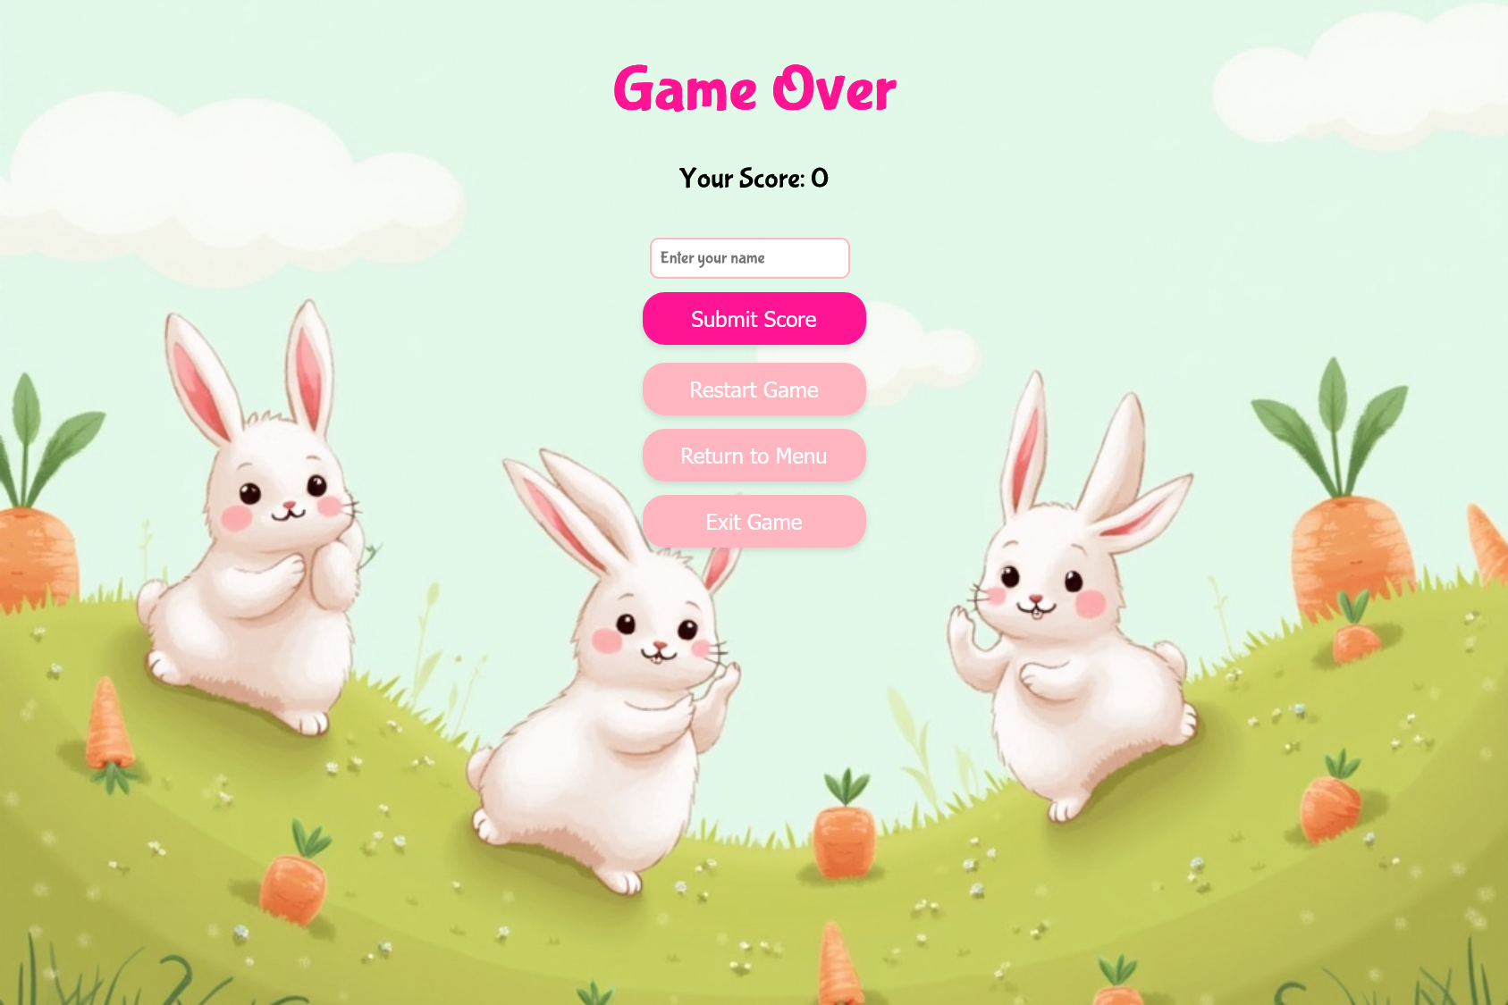

Features and Mechanics

1. Dynamic Background:
- - The environment evolves as you climb higher, giving a sense of progress and excitement.

2. Physics-Based Movement:
- - Enjoy realistic jumping and movement physics. The rabbit accelerates smoothly, decelerates naturally, and responds accurately to your commands.

3. Scoring System:
- - Earn points for every platform you jump on.
- - Collecting carrots adds a significant boost to your score.

4. Game Over Conditions:
- - Falling off the screen.
- - Colliding with a bomb.

5. High Scores:
- - Challenge yourself to beat previous scores. The game tracks the top performances so you can aim for the leaderboard.
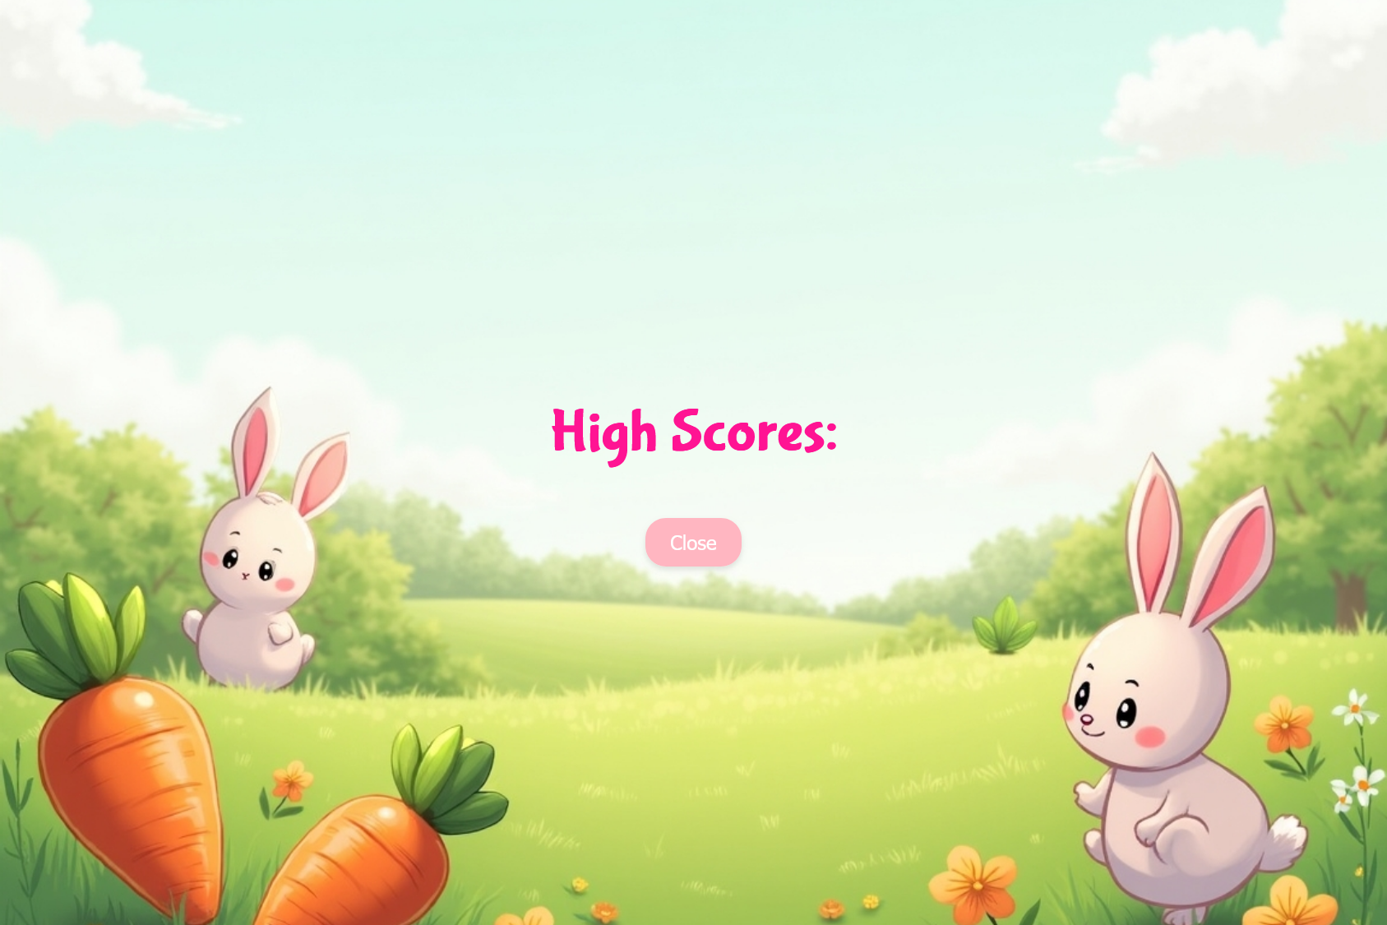

Tips and Tricks
- - Master the Controls: Practice moving left and right to land precisely on platforms.
- - Plan Ahead: Look ahead to anticipate the placement of platforms and adjust your movements accordingly.
- - Stay Centered: Landing near the center of platforms gives you more time to react to upcoming obstacles.
- - Avoid Bombs: Bombs appear without warning. Keep your movements fluid to evade them easily.
- - Carrot Priority: While carrots boost your score, avoid risking a fall or bomb collision to grab one.

Contributions to the project
James McGuigan: What I’ve Worked on for This Project
- Analysis Documentation: Wrote the functional and non-functional requirements to ensure the project meets user needs and technical specifications.
- Design and Development: Introduced a design concept and overview of the design and design development processes to document the project's architecture and workflow.
- Code Contributions: Implemented game characters, ensuring they aligned with the project vision. Created physics and functional bounds to enhance game mechanics and overall playability. Set up and designed the HTML and CSS for dynamic design and styling, ensuring a responsive interface for this game.
- Database Integration: Assisted in setting up the database using SQL and PHP, for data management and storage with the username entries and score.
- Server Hosting: Set up and hosted an AWS server to provide a web-based platform for the project, ensuring accessibility and reliability.

Ariana Brown: What I’ve Worked on for This Project!
- Analysis Documentation: I wrote the Introduction and Overview section. In the introduction, I explained what to expect in Carrot Quest including game mechanics. In the Overview, I explained who the protagonist was and their objective. Additionally, I explained how users will play the game, the obstacles they will have to face, and the visual and scoring systems we plan to implement
- Design Document: During the design document I explained the software architecture of our game. This consists of subsystem Decomposition, Hardware/ Software, Persistent Data Management, Access Control and Security, and Boundary Conditions. In addition, I did 2 graphs in this document
- Code Contribution: Mainly helped with creating the obstacles (the bomb ) and when the rabbit detects a collision with the obstacle. Also helped assist with visuals using html and assisted with bug testing. For example, there was a bug when the scores were not saved. Also, there was a bug where you hit the bomb your score would be 0. Both had to be addressed immediately.
- Final Document: In the final document, I did the sections Introduction and Implementation

Jugraj Samra: What I’ve worked on for this project!
- Analysis Document: Worked on the glossary, and contributions section of the analysis document. Co-Editor.
- Design Document: Worked on Section 3 of the document, and made various diagrams.
- Final document: Worked on the user guide/system requirements section.

Adan Solano: What I’ve Worked on for This Project
I focused primarily on working with the development team to better understand our game functionalities and then translating those technical concepts into accessible language. This involved researching, organizing, and presenting various architectural, interface, and gameplay concepts logically and coherently (Design Document). I also wrote a comprehensive “How to Play” guide, which not only outlined the key rules and mechanics of the game but also introduced helpful tips to improve the overall user experience.
Additionally, I took on the task of testing the game for any potential bugs or issues by performing thorough playtesting, ensuring that the final product was as stable, intuitive, and engaging as possible.
Steven Foster: What I’ve Worked on for This Project
- Analysis Documentation: I wrote Sections 6 - Use Case Models, 7 - Sequence and Dynamic Models, 8 - Object and Class Models, and 9 - User Interface for this Assignment as well as creating all of the Diagrams used within.
- Design Document: Worked on Section 4 of the document. I Worked on Subsections 4.1 - 4.6. I added most of the diagrams.
- Final Document: I added the Game Design and Changes section to this document.
- Database Integration: Assisted in setting up the database using SQL and PHP, for data management and storage with the username entries and score.

Project Link:
Click Me!
Link 1: http://ec2-52-87-244-187.compute-1.amazonaws.com/CarrotQuest.html
Link 2: https://tinyurl.com/CQ121624

